Slip Stitch or Blind Hem Stitch
These are two names for the same stitch. This stitch is intended to secure a hem or join two folded edges without being noticeably seen from the right side of the fabric. Take a look at the diagram below:
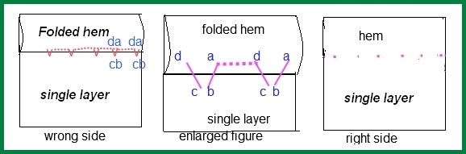
Hem: Folded twice (fold once and press, then again and press) to make a tube of fabric that creates a finished edge at the desired length. Hems are found at openings of fabric, especially pants and skirt bottoms and sleeve ends.
Slip stitch: The dotted line in the first two images represents the slip part of the stitch. It is called a slip stitch because the needle and thread literally slips through the fold in the fabric.
Take-up stitch: In the take up stitch, your intention is to take up one to two threads only of the fabric with your needle. This produces the smallest possible stitch which can barely be seen from the right side, as shown in the third image.
Tips for the blind hem stitch
- Do NOT pull hard. Even a little bit. You want the thread taut but not tight.
- Pin the folded and pressed hem down with about 4 inches between pins before beginning to sew.
- Stab perpendicularly directly into the fold, then swing the needle sideways.
- The take up stitch needs to be directly on the hem line, not floating above the hem or hidden by the fold. The image shows the take up stitch floating above the hem just a little for your reference only. Keep it closer!
- Take up stitches should be no more than one inch apart.
- After you tie off, do not cut the needle. Instead take one last extra long slip stitch and bunch the hem up around it. When you pull the needle back out, cut close to the hem so the thread tail is hidden inside the hem when you un-bunch the hem.

