Name: ______________________________________
Date: ___________
PARTS OF A SEWING MACHINE WORKSHEET
Today's sewing machines maximize your sewing experience with their ease of operation, and professional results. The parts of a sewing machine are easy to identify.
Models and makes of sewing machines differ in layout and features, but the basic parts are similar.
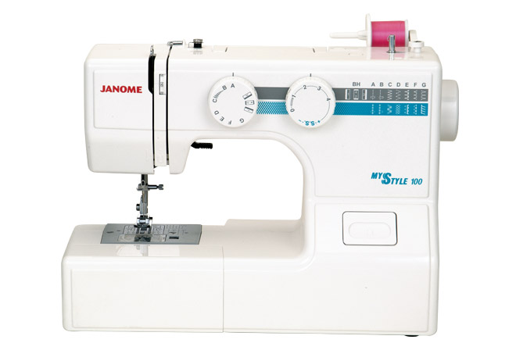
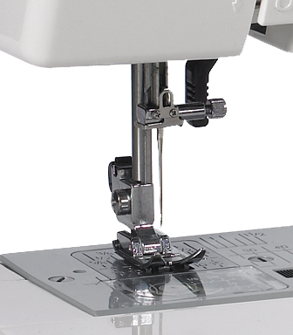

Parts of a Sewing Machine

- __________________________________________
- __________________________________________
- __________________________________________
- __________________________________________
- __________________________________________
- __________________________________________
- __________________________________________
- __________________________________________
- __________________________________________
- __________________________________________
- __________________________________________
- __________________________________________
- __________________________________________
- __________________________________________
- __________________________________________
- __________________________________________
- __________________________________________
- __________________________________________
- __________________________________________

