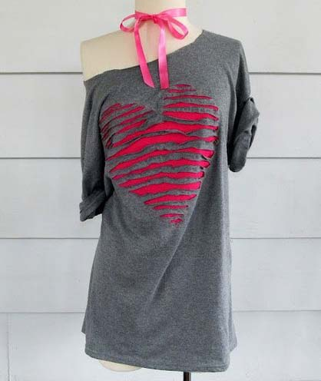
We kindly thank Anne for allowing us to re-post her wonderful idea on how to make this gorgeous T-shirt , simply perfect for any occasion.
You'll need:
- Tee-Shirt
- Scrap piece of T-Shirt in a contrasting color, or just a scrap piece of material to cover the heart you make
- Sewing Machine
- Scissors
- Straight Pins

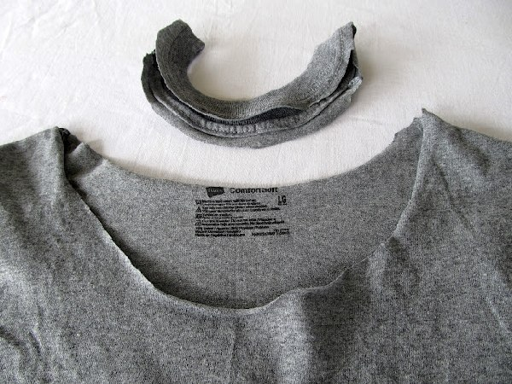
First cut your collar off to make your shirt an off the shoulder shirt (this one was cut right around the edge of the collar).
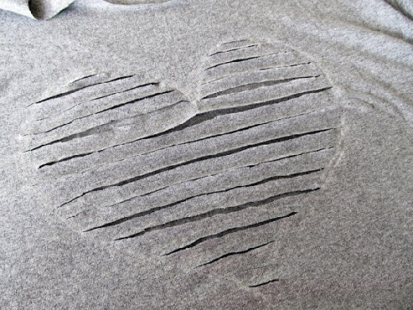
Draw a heart on your shirt with chalk or outline a paper template. Inside your heart, draw lines 3/4 of an inch apart. Carefully cut the lines inside the heart.
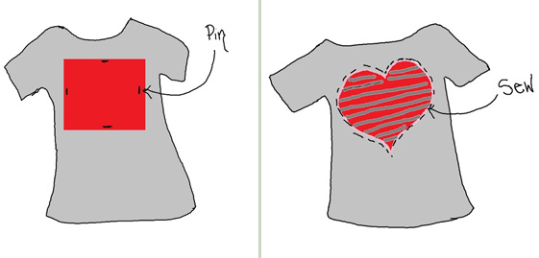
Turn your shirt inside out and place your scrap piece of material over the heart and pin it.
Turn it back right side out and sew around the edge of the heart.
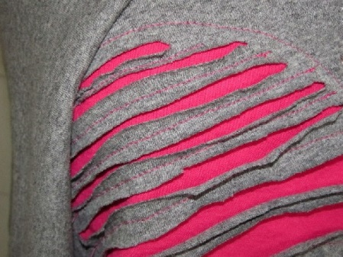
Now sew each one of the grey stripes down the middle,this will anchor the heart so it keeps its shape.
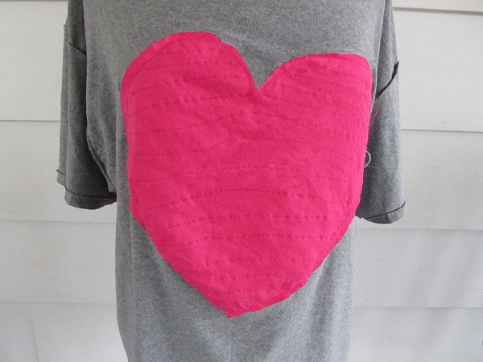
Turn your shirt inside out again and trim the excess material around the heart and trim any leftover thread. Voila! You have a new gorgeous outfit!

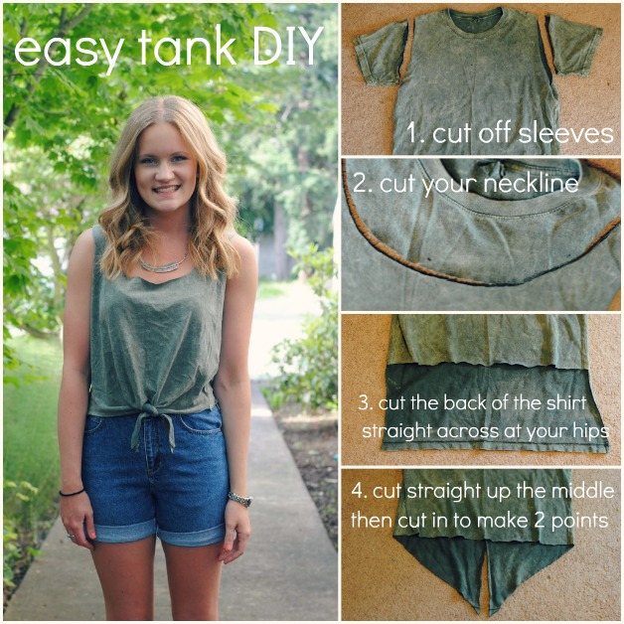

Take it one step further and cut the shoulders off.
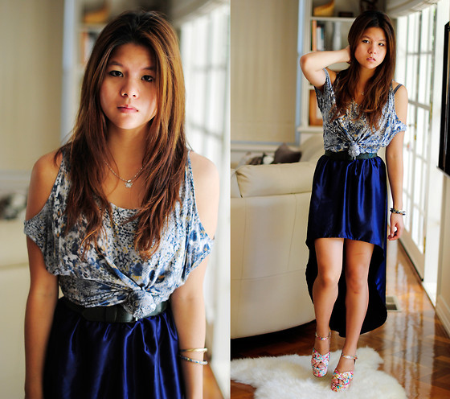

No Sew, Tee-Shirt Halter #3, DIY

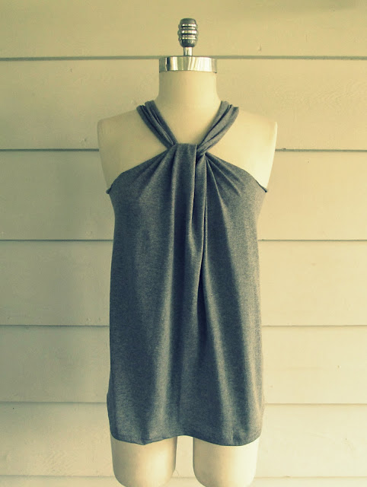

I have the exciting opportunity to head to the beach for a couple of days, to relax and soak up a little of that beautiful Florida sunshine. I wanted to do one more halter top to take to wear with my jeans and this is what I came up with. It can be changed in so many ways let's just say this is a 3 in one shirt. It seems like I am packing all of my DIY tops and dresses to wear.
Other DIY Halters HERE and HERE !!

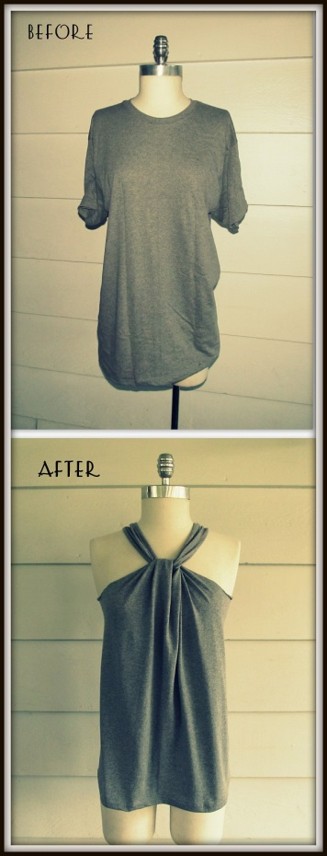

Tutorial
Things You Need.
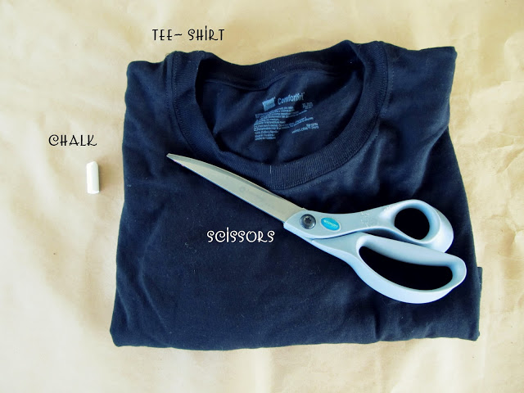
- Tee-Shirt~ mine is a mens medium
- Scissors
- Chalk
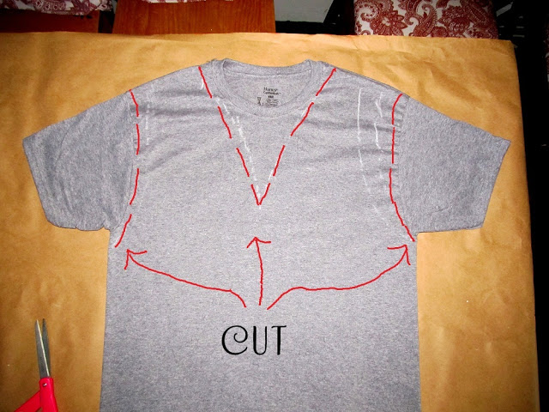
Front
Cut where the red lines are.

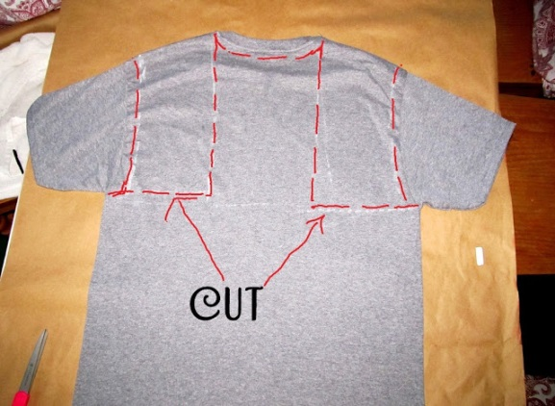
The back
cut the red lines

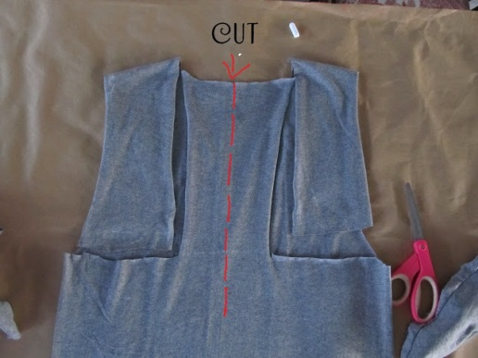
Back
Cut down the middle of the back cut out..

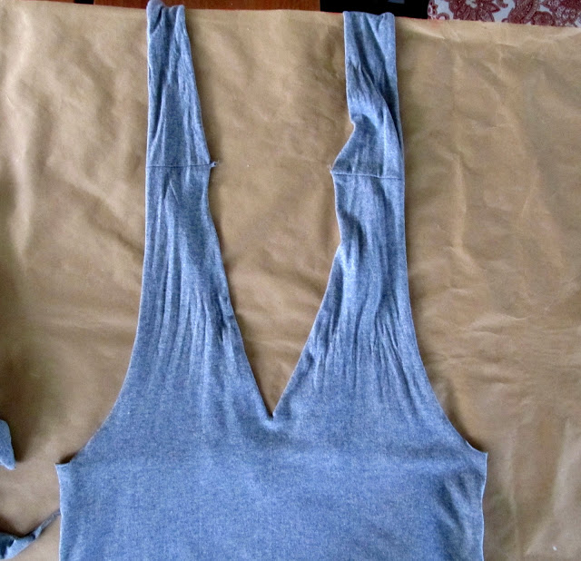
Front after cutting
NOTE* you cut one continuous line from the front to the back.
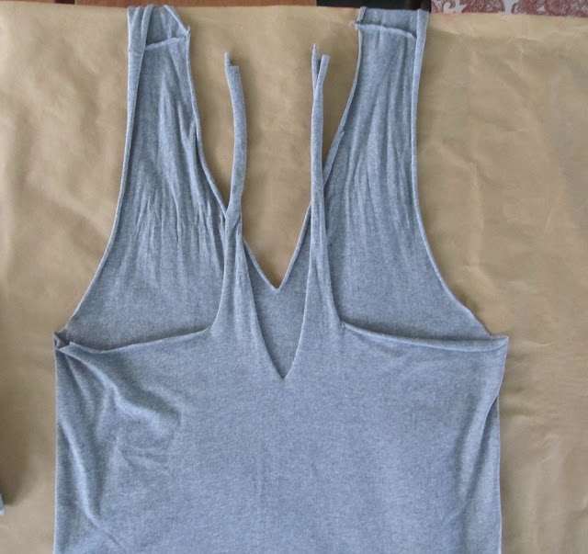
Back After cutting

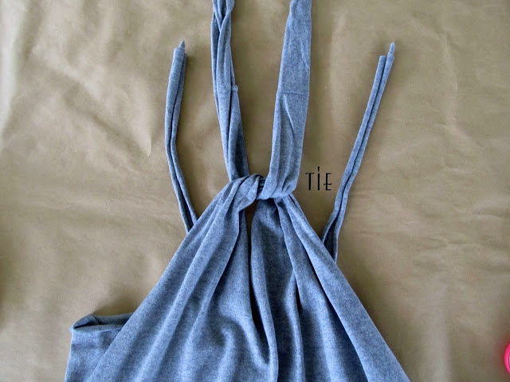
now tie the front
wrap around your neck
and tie to the two straps in the back.
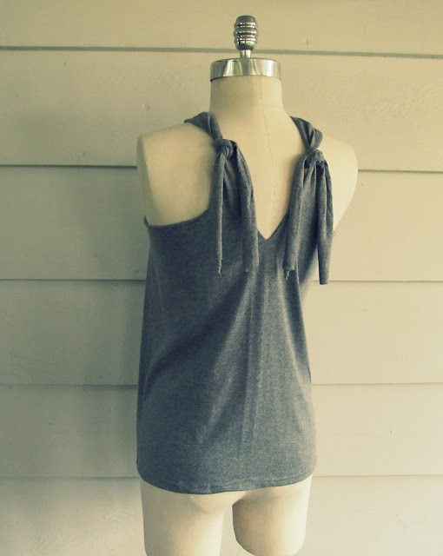

If you want to trim off the excess off the straps.
I am leaving mine so I can play and change it up some more..
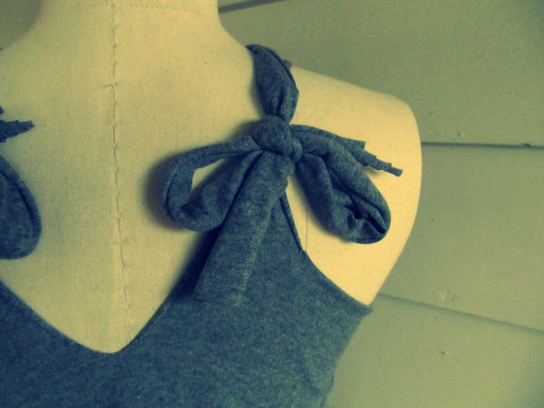
or tie them into a bow.

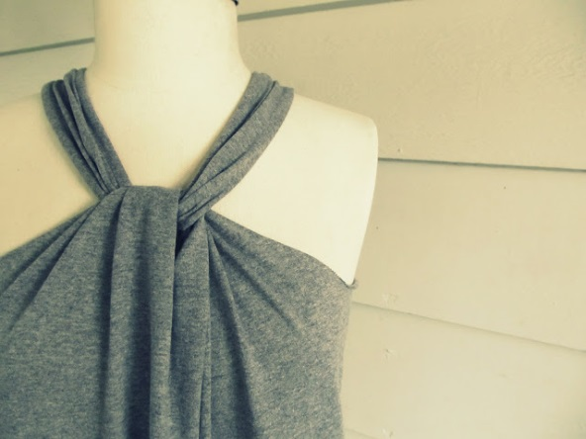

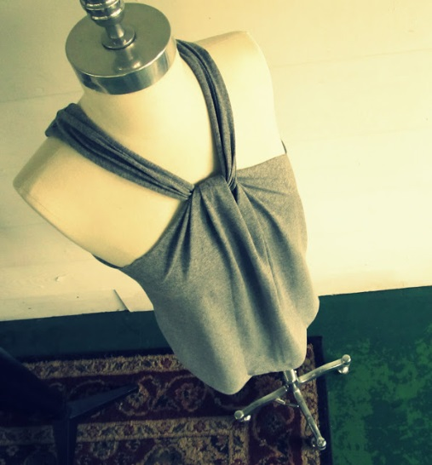

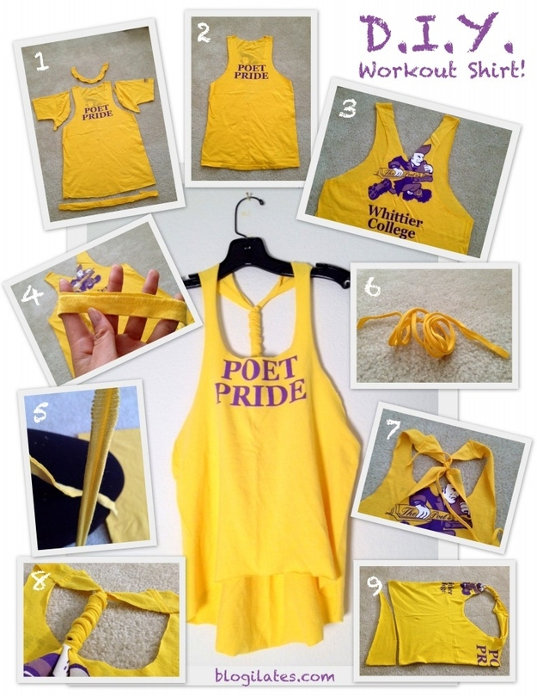

DIY Oversized Cropped Tank or Vest from a T-shirt
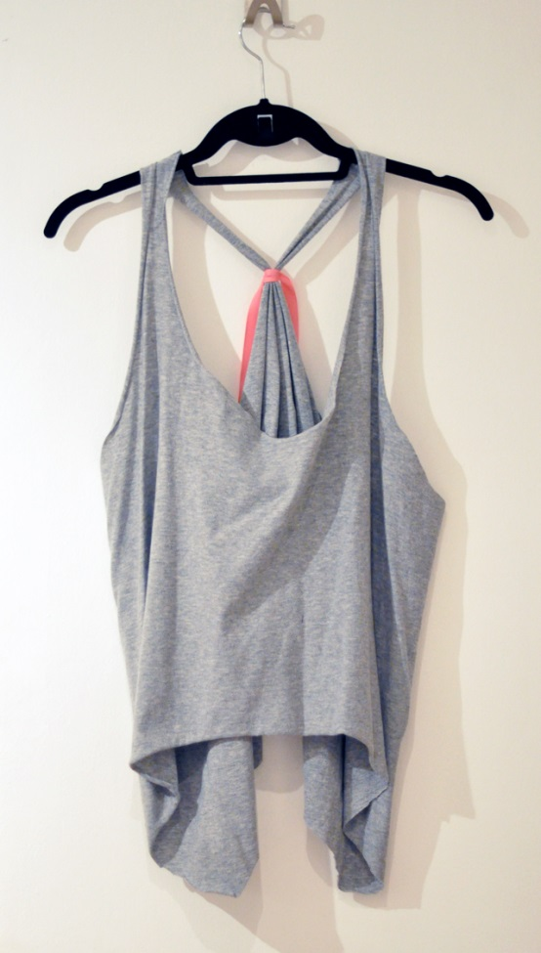

What you’ll need. . .
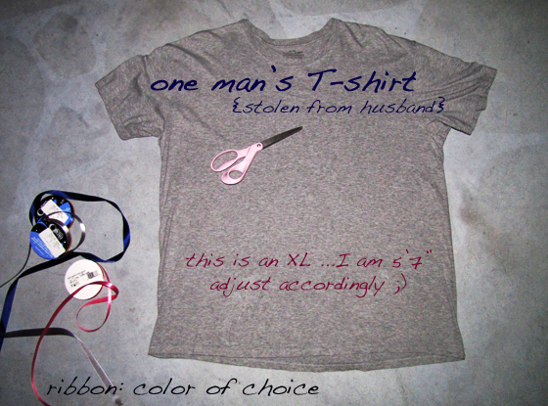
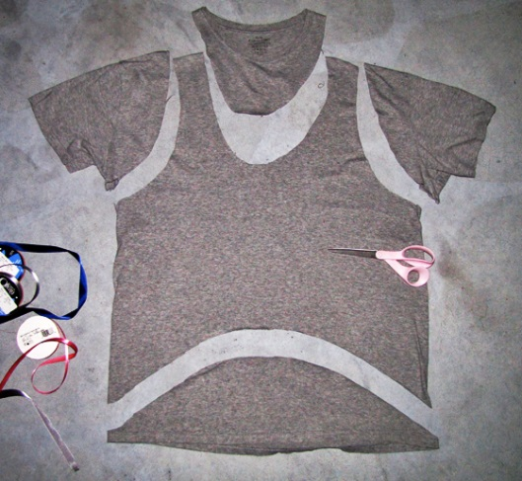
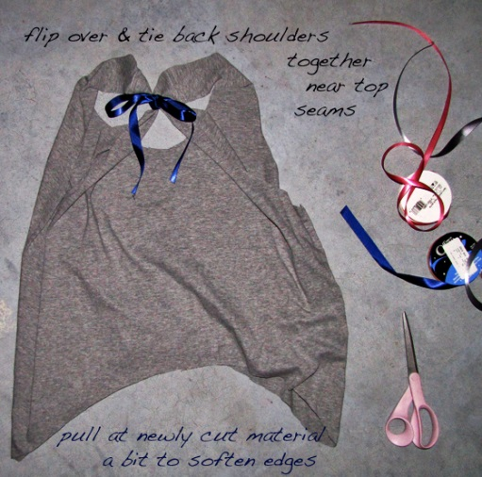
* NOTE: as you wear it the edges will curl a little …which actually makes it look better
for a cropped look, pull it back more or cut the center shorter
* NOTE #2: instead of ribbon you can cut strips out of the left over t-shirt, shoe laces, lace, anything!

Voila!
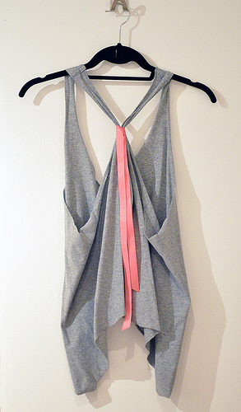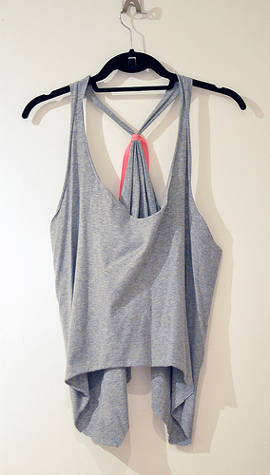
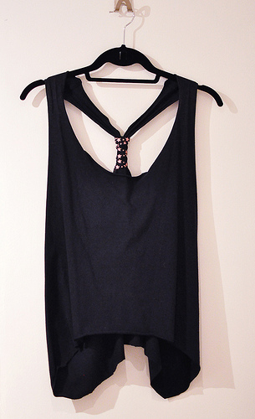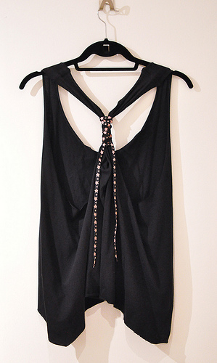

Gucci Inspired Cut-out T-shirt DIY

Here’s What you’ll Need…
* Fitted t-shirt {non-stretch is preferable}
* Scissors
* Chalk or white pencil
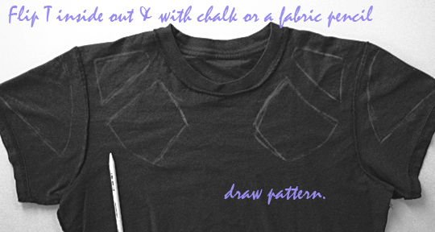
* Flip t-shirt inside out and draw your design.
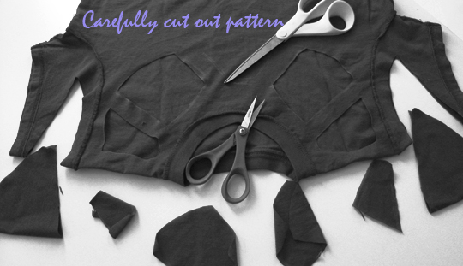
* Carefully cut out your pattern.

And… Voila!
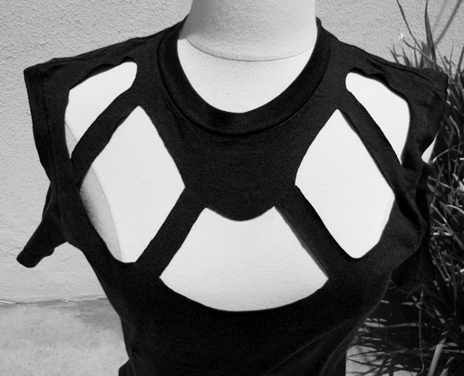
If you use a thick jersey/high quality t-shirt, you should be able to wash and dry this t-shirt without any fraying/etc. The edges may curl up a bit, but not much. If it’s a brand new t-shirt and you like the way it fits now, wash it in cold and hang it to dry.

Whenever I go out to the shops I always look at plain shirts and dresses whenever they're on sale. I got this shirt for $3 from supre. Pretty good :) Here's a tutorial on how to achieve this look.
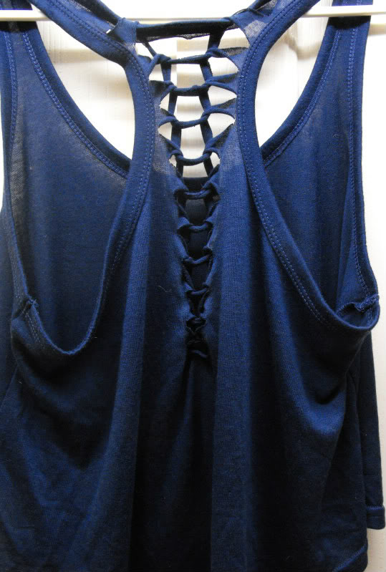
Step 1
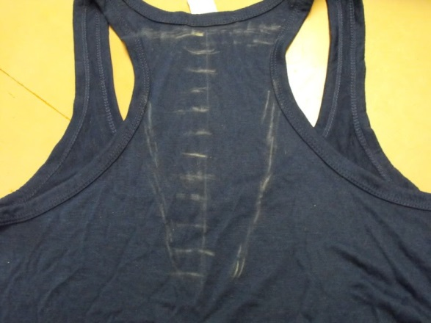
Lay the shirt flat and mark out the middle of where you are cutting. Then mark out each line, I did mine 2cm apart. Also mark out how far out you will cut to, I did mine in a v-shape.
Step 2
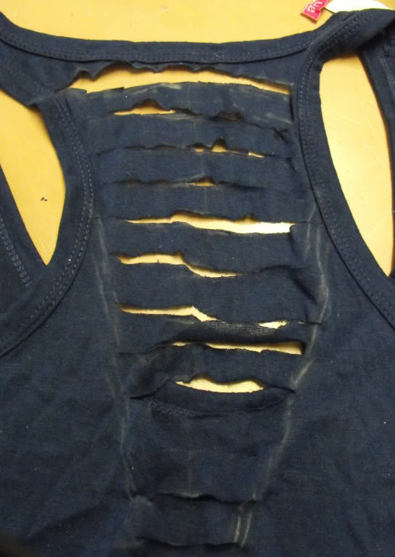
Cut out the strips, it does not have to be perfect, you won't notice in the end result.
Step 3
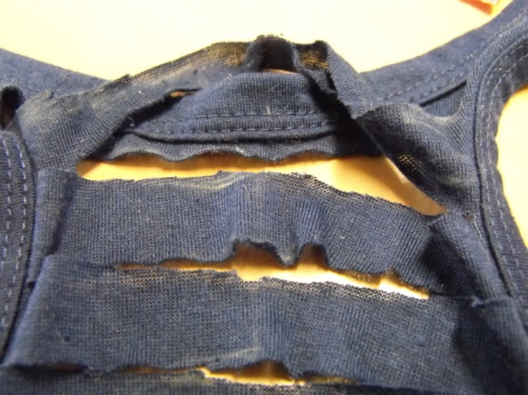
Grab the second strip and place it on top of the first strip.
Step 4
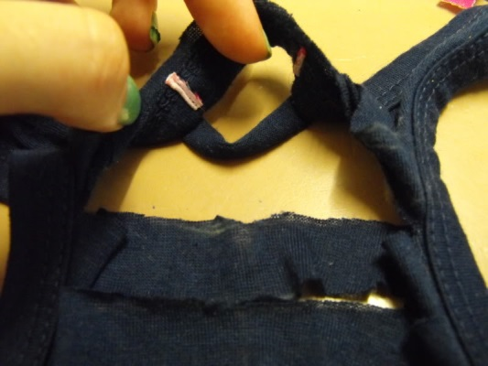
Pull the second strip under the first strip.
Step 5
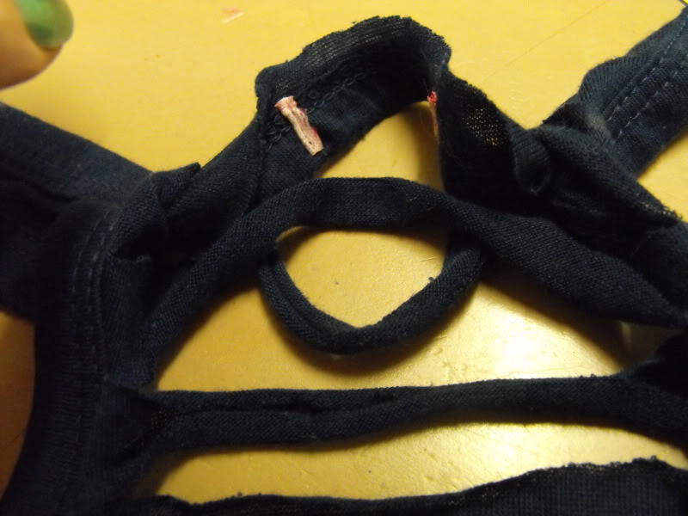
Place the third strip on top of the loop of the second strip, repeat until you reach the end.
Step 6
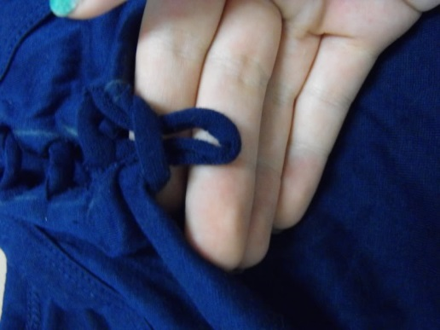
When you've reach the end of the strips, take the loop to the inside of the shirt and handstitch it into place.
Now you should be finished :) Here's a photo of me wearing the final product. This technique can be applied to anything, as long as the fabric is knitted and not woven, so it doesn't fray.
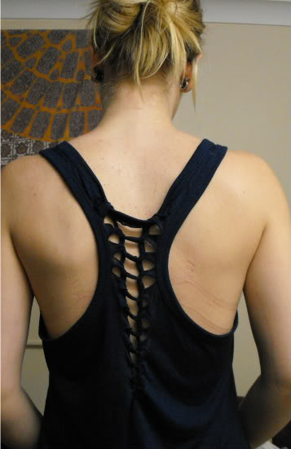

Supplies: Wide shirt/sleeveless
1 yard fabric.
Fabric should be light with drape and stretchy.

Where we currently live it's warm year round so summer DIYs are still on my mind... I love my diy twisted tee and wanted to do one that was horizontal. This effect is so simple and transforms your old tshirts into an interesting twist.

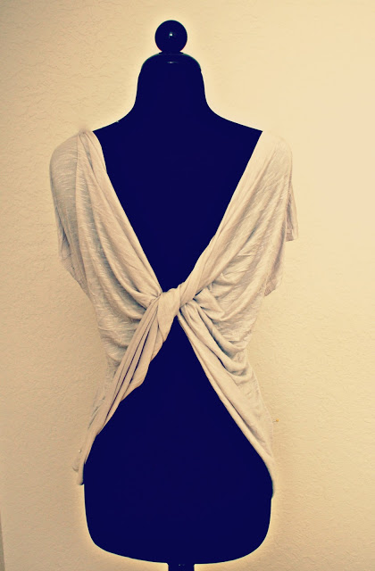

DIY:
First, you will want a wide shirt that isn't very long. I made the pattern, you can easily do this by using a sleeveless shirt and cutting out the pattern on your desired fabric.
Here is a really quick video of the process...

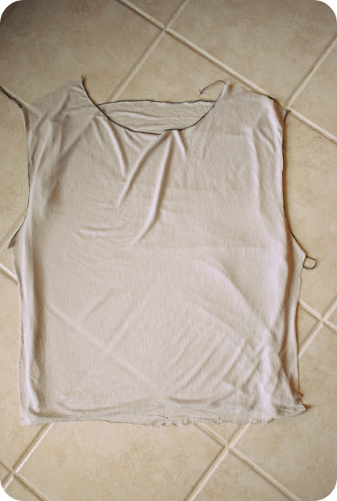
Cut the shoulder and side seams of one side of the sleeveless shirt.
Place them right sides together. Mine was a pattern I made so all sides are cut.
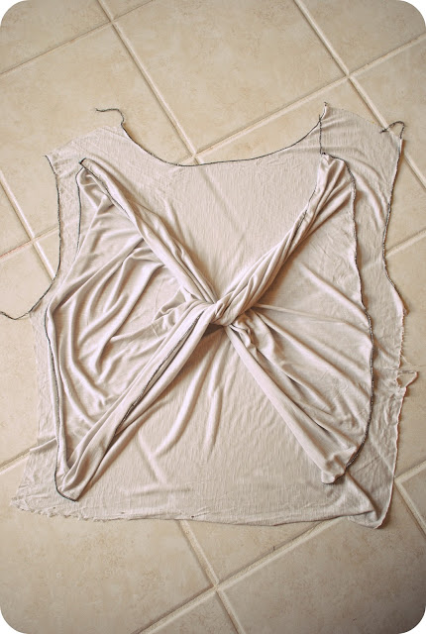
Twist the shirt so the right sides meet together. Basically all the way back around...
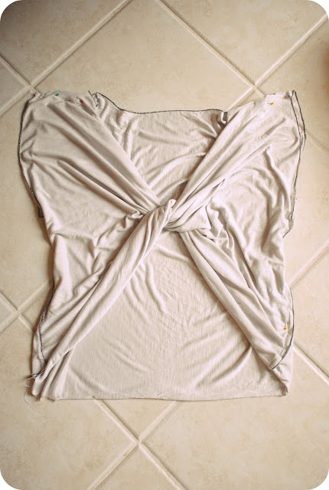
Pin the seams together and sew them...

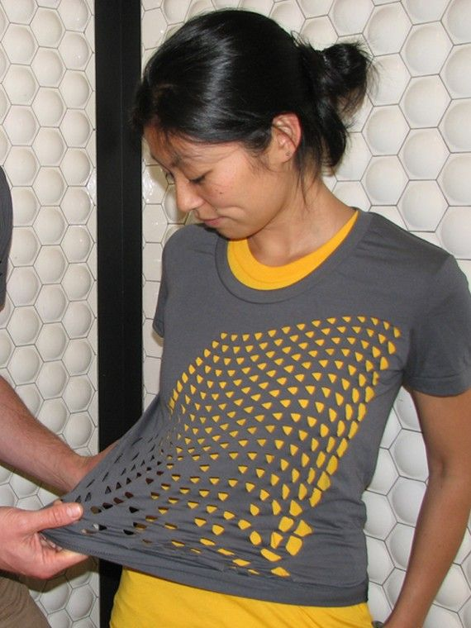

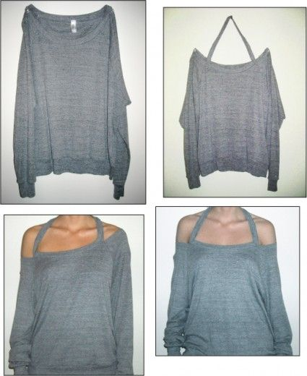

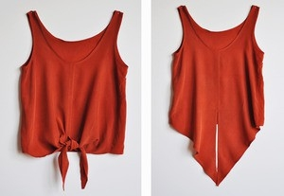
This summer, cutout and low back t-shirts have been extremely popular – you can find them in almost any store! These shirts are a perfect way to achieve a summery vibe and beat the heat. One of my favorite styles is the bow back t-shirt (see above); it creates such an effortlessly girly and chic look, and can easily be tucked into a skirt or worn with your favorite denim cutoffs. This DIY will show you how to make your own bow back t-shirt from an old tee you have lying around.

What you’ll need:
- An old t-shirt – although any cut will work, a scoop or crew neck will work best for this DIY
- Scissors
- Needle and thread OR sewing machine
- Seam ripper (Optional – for fixing mistakes!)

How to:
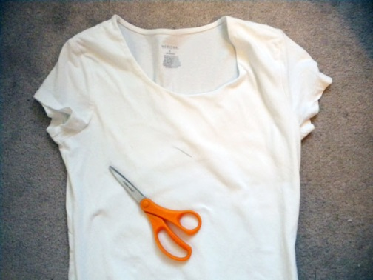
1. First, make sure your shirt has been washed and dried if it’s new. Lay it out so you are looking at the back of the shirt, making sure that the seams on each side are even and the entire shirt is flat. On the back of the shirt, make light pencil markings for how wide you want your cutout area to be, and how far down the shirt you want it to go (see the finish product at the end of the post for an idea of where mine was).
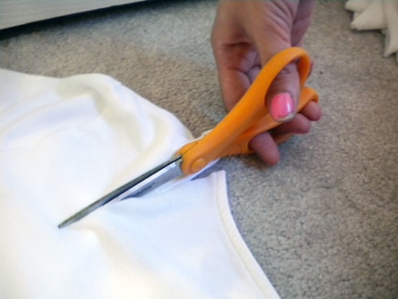
2. Begin cutting one half of a “U” shape in the back of the shirt. Make sure you don’t cut through both sides! Try not to pull or move the shirt too much while you cut, and avoid closing the blades of the scissors all the way so you don’t get jagged edges. Once you have cut half of the U shape, stop cutting.
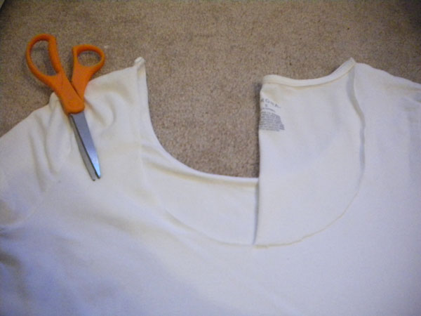
3. Fold the half “U” over to the other side of the shirt to use it as a guide. Cut along so both sides are even.
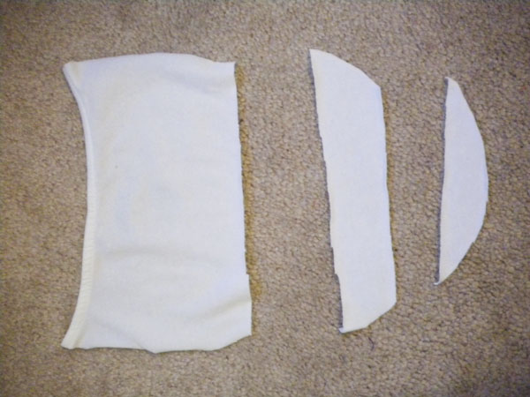
4. Cut out the pieces for your bow. Cut off the top of the “U” to make a rectangle, about 4 to 5″ tall. Cut another strip of fabric, about 1 inch tall. You should end up with 3 pieces, similar to the ones shown. You will only be using the top two pieces.
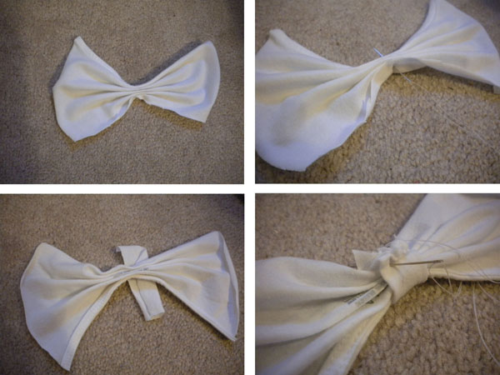
5. Make your bow using the fabric you just cut. Fold the larger rectangles like a fan- the folds should be horizontal. Pull your needle and thread through the center to hold the folds in place. Then, using the strip of fabric, wrap the center of the fan. Cut off the excess length, and sew along the edge to form a loop. Your bow is complete!
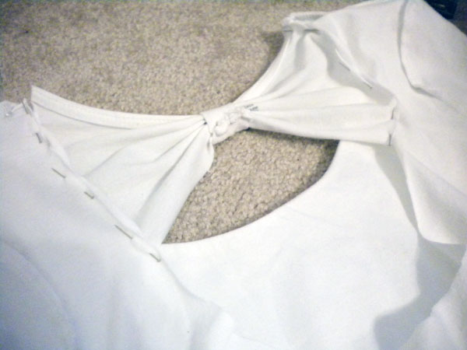
6. Align your bow. I found mine looked best when it was at the top so the neckline was continuous, but you can put it lower if you want. Turn your shirt inside out, then pin the bow so that the side of the bow you want facing outward is facing in, too. In other words, you’ll be looking at the “inside” of the finished product when you sew, so that the seam will be on the inside of the shirt. Try the shirt on inside out while it’s still pinned to make sure you like where the bow is.
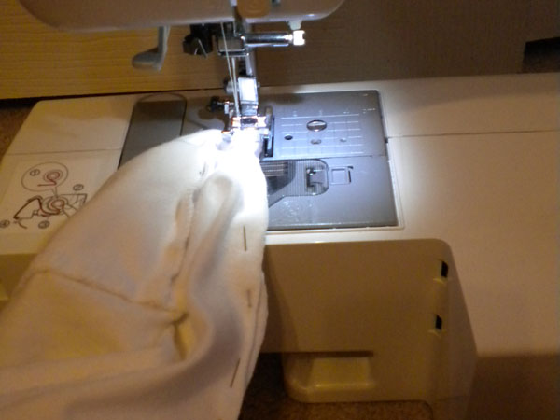
7. Sew your bow in place. Make sure you knot or backstitch, since this area will receive a lot of strain. Turn your shirt right side out, and you’re done!
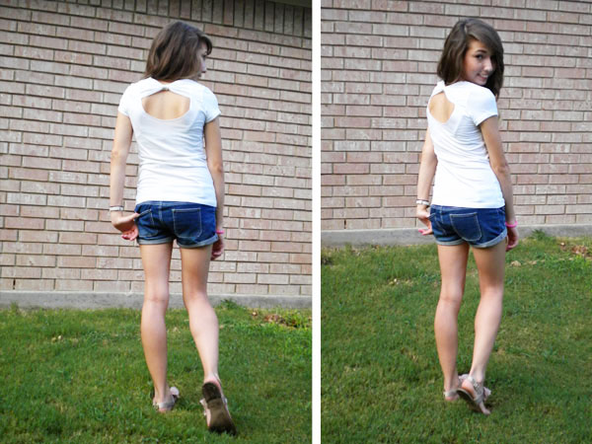
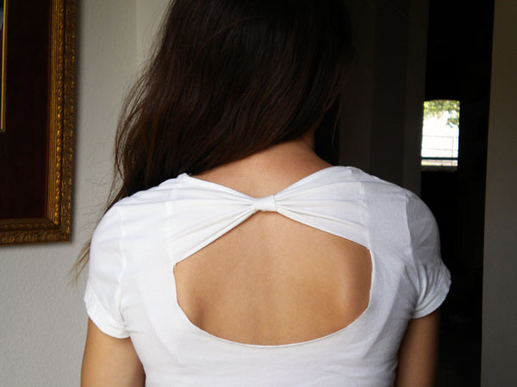
You could also add more bows if you want, or even cut out the entire back and make bows all the way down. The amount of the back you cut out can completely change the look of this shirt. Don’t let the idea of sewing scare you. Although a needle or sewing machine may seem daunting, it just takes a little practice and patience! And if you do mess up, you can use a seam ripper to tear out any seams you messed up on. If you don’t have a seam ripper, you can also use a pair of scissors, you’ll just have to be extra careful. Most mistakes in sewing are fixable, so don’t stress – just be

Swim Suit Cover for the Kids

DIY Bleach Splash Swim Suit Cover
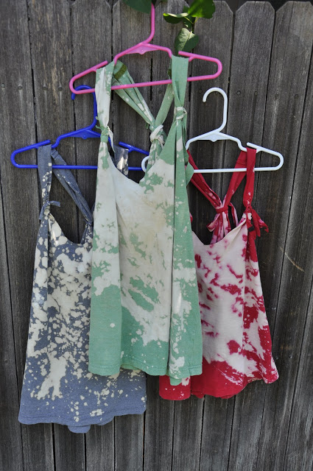
I saw this idea on Pinterest for adults. When I was making them it dawned on me that it was not going to fit me but decided to alter just slightly so they would fit the girls!
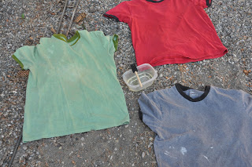
All you will need is an old t-shirt from the back of the closet and bleach.
First place your shirt in an area that you don't mind getting bleach on...
And splash away...
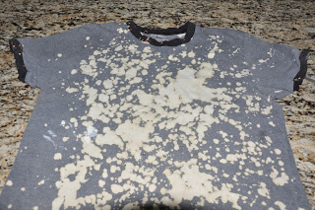Some of it will take about an hour to change color completely and others will change almost immediately. Give it time to dry completely before adding more bleach, you can always add, you can't take away...
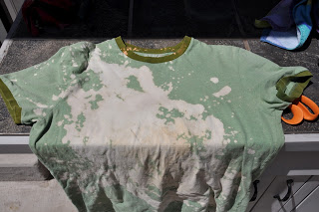Then cut the neckline and sleeves off. I cut a little deeper on the first one thinking it might be for me but being for the kids I wouldn't cut as much out, same with the arm holes.
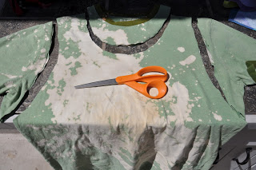
Then take one of the strips that you cut out and tie the back sleeves together. Slide the tie almost to the shoulder seams. This will pull it down in the back but make it just the right size for little ones. I also added ties to the front of the cover. I wouldn't do this for myself but again, it made it look more their size. (2nd tie goes between the neckline and sleeve.)

