What Is a Galaxy?

By Nola Taylor Redd 1/4/2019 Science & Astronomy

If you gaze out into the night sky with a telescope, and see beyond what’s visible to the naked eye, you'll see a lot of stars that are actually imposters. Some of those points of light are actually galaxies. A galaxy is a huge collection of gas, dust, and billions of stars and their solar systems. All these pieces of a galaxy are held together by gravity.

Astronomers aren't certain exactly how galaxies formed. After the Big Bang, space was made up almost entirely of hydrogen and helium. Some astronomers think that gravity pulled dust and gas together to form individual stars, and those stars drew closer together into collections that ultimately became galaxies. Others think that the mass of what would become galaxies drew together before the stars within them were created. Astronomers are constantly refining their techniques of measuring the mass of individual galaxies which affects their theories about how they were formed.

Galaxy Characteristics
Most galaxies have black holes at their centers. These black holes produce a tremendous amount of energy which allows astronomers to identify them over great distances. Astronomers classify galaxies into groups by their shape. Each type has different characteristics and a different history of evolution.
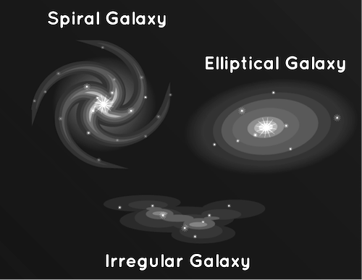
Some galaxies have arms spiraling outward around their center and are known as spiral galaxies. These groups make up most of the galaxies that astronomers can see. The gas and dust in a spiral galaxy circles the center at speeds of hundreds of miles per second, creating their pinwheel shape. There are a lot of dust clouds and gas in spiral galaxies which leads to the ongoing formation of new stars.
Elliptical galaxies lack any spectacular spiral arms. Their appearance is egg shaped and ranges from circular to very stretched out. Elliptical galaxies have less star making gas and dust clouds than their spiral counterparts, so there is little new star formation occurring in them. Most of their stars are older. Although they make up a smaller portion of the visible galaxies, astronomers think that over half the galaxies in the universe are elliptical.
The remaining 3 percent of the galaxies in the universe are known as irregular galaxies. They are neither round, nor contain spiral arms. Irregular galaxies, as their name suggests, are irregular in shape. The gravity of other galaxies has often affected them, stretching them out or warping them. Collisions or close calls with other galaxies can also deform their shapes.
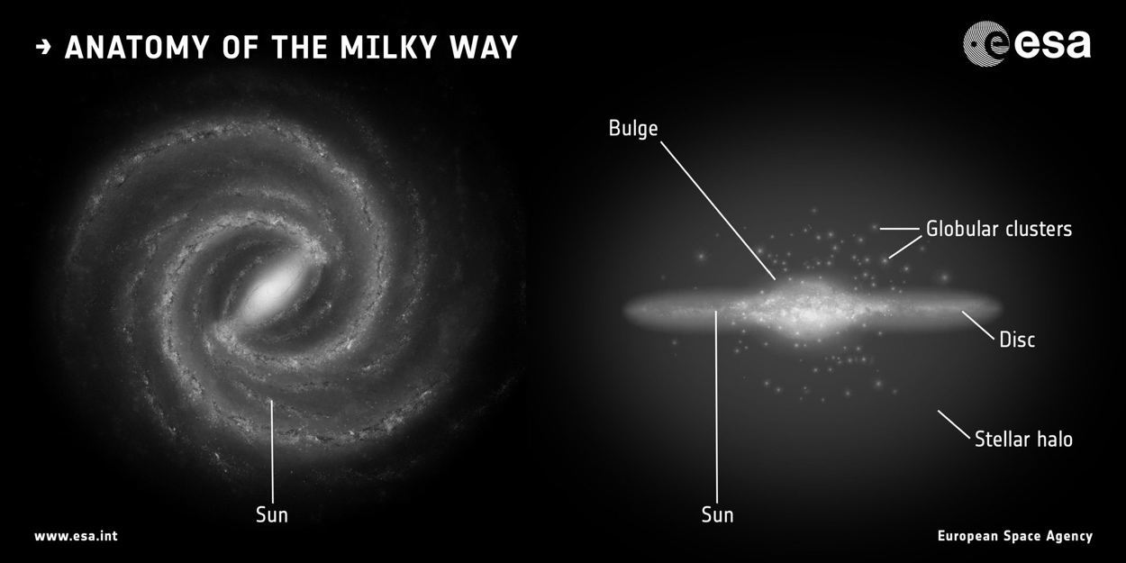
We live in one of the arms of a large spiral galaxy called the Milky Way Galaxy. The Solar System (the Sun and its planets, including Earth) lie in this quiet part of the galaxy, about half way out from the center.
The Milky Way is shaped like a huge whirlpool that rotates once every 200 million years. It is made up of at least 100 billion stars, as well as dust and gas.

The Milky Way galaxy is so big that light takes 100,000 years to cross from one side to the other. The center of the Galaxy is very hard to see because clouds of gas and dust block our view. Scientists think that it contains a supermassive black hole that swallows anything passing too close. The Milky Way Galaxy is known as a "barred spiral." Unlike a regular spiral, a barred spiral contains a bar across its center region, and has two major arms. The Milky Way also contains two significant minor arms, as well as two smaller spurs.
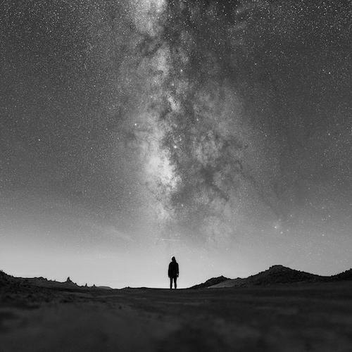
When you look up at stars in the night sky, you’re seeing other stars in the Milky Way. If it’s really dark, you can even see the dusty bands of the Milky Way Galaxy stretch across the sky.
There are many, many galaxies besides ours, though. The Hubble Space Telescope looked at a small patch of space for 12 days and found 10,000 galaxies, of all sizes, shapes, and colors. Some scientists think there could be as many as one hundred billion galaxies in the universe.
Source:
https://www.space.com/15680-galaxies.html & https://www.esa.int/kids/en/learn/Our_Universe/Stars_and_galaxies/The_Milky_Way

