BASES

____________________________________________________

Origami Kite Base
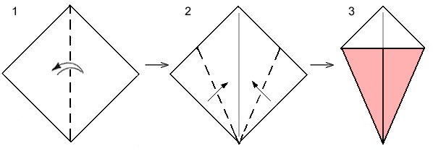 Take a square sheet of paper and position it so it looks like a diamond (a square balancing on one of its corners).
- Fold the paper in half from right to left. Unfold.
- Fold the bottom-right and bottom-left edges of the paper to align with the central crease made in step 1.
Done! This is the completed origami kite base.

Origami Fish Base
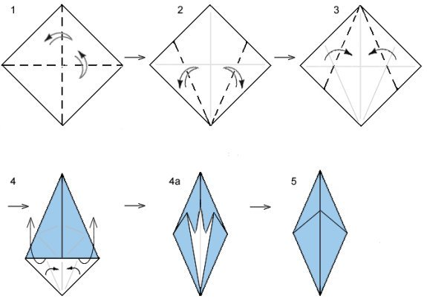
- Take a square sheet of paper and position it so the corners of the paper point up and down.
Fold the paper in half from right to left. Unfold.
Fold the paper in half from top to bottom. Unfold.
- Fold the bottom-right and bottom-left edges of the paper to align with the central, vertical crease. Unfold.
- Fold the top-right and top-left edges of the paper down to align with the central, vertical crease.
- Redo the folds in step 2 while you lift the edges of the paper upwards. Step 4a shows the transition step.
Done! The origami fish base is a diamond shape with a small flap in front. As its name implies, this base is used to make origami fish.

Origami Waterbomb Base
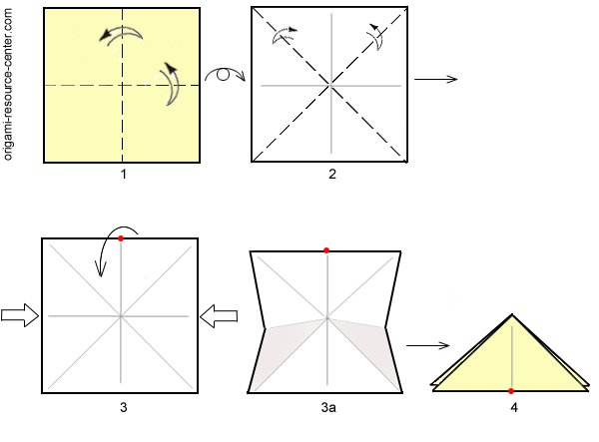
- Start with a square sheet of paper with the colored side facing up.
Fold the paper in half from right to left. Unfold.
Fold the paper in half from top to bottom. Unfold.
- Flip the paper over so the white side is facing up.
Fold and unfold from corner to corner in both directions to get an X crease.
- Fold the top-edge of the paper down while you push the right and left edges inwards. Step 3a shows the transition step. Use the location of the red dot to help visualize the process.
Done! The origami waterbomb base looks like an isosceles triangle with a total of 4 flaps. The typical orientation is to have the flaps arranged two on each side. Some models might have all 4 flaps stacked on one side, or the flaps may be flared open like a star.

Origami Preliminary Base
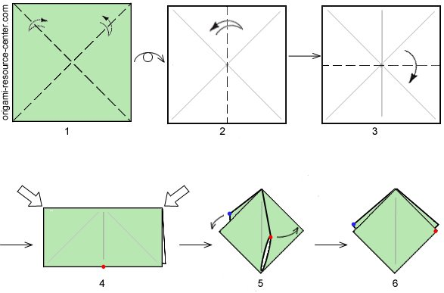
- Start with a square sheet of paper with the colored side facing up.
Fold the paper along the diagonal in both directions to form an X shaped crease. Unfold.
- Flip the paper over so the white side is facing up.
Fold the paper in half left to right. Unfold.
- Fold the paper in half top to bottom.
- Push the right and left edges inwards towards one another. A flap of paper will come towards you (red dot) and another flap will be created behind the model (blue dot).
- Swivel the front flap to one side. Swivel the back flap the other direction. Use the location of the dots to help visualize the process.
Done! The origami preliminary base looks like a square that is ¼ the size of the original paper. It has a total of 4 flaps. The typical orientation is to have the flaps arranged two on the left and two on the right.

Origami Bird Base
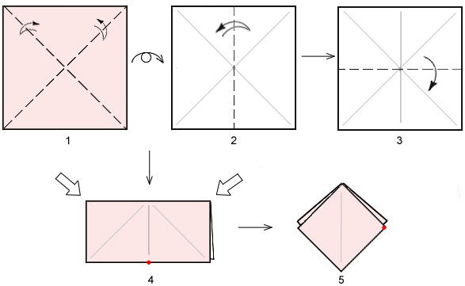
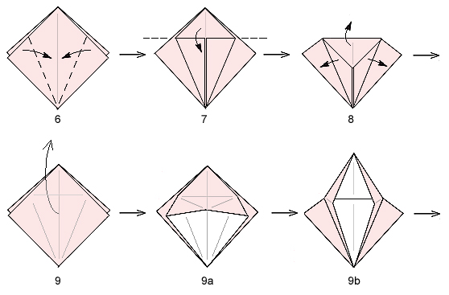
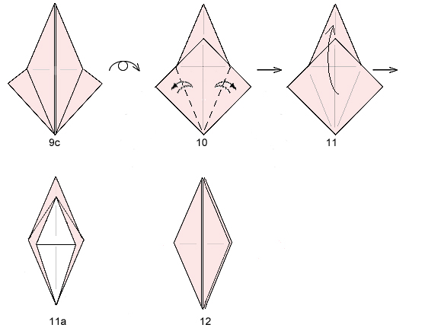

- Start with a square sheet of paper with color-side facing up.
Fold and unfold along the diagonal in both directions to get an X crease.
- Flip the paper over so white-side is facing up.
Fold in half from left-to-right. Unfold.
- Fold the paper in half from top to bottom.
- Push the left and right corners inwards towards one another until new flaps of paper are formed in front and behind.
- Swivel the flaps to the side. Follow the red dot to visualize the procedure. This is also called the preliminary base.
- Work with the top layer only. Fold the left-edge and right-edge of the paper inwards so they align with the central crease.
- Fold the top of the model down. Use the flaps made in step 6 as a guide.
- Unfold the last 2 steps so you are back to the preliminary base (step 5).
- Lift the top flap upwards along the creases made in steps 6 & 7.
Steps 9a & 9b show transition steps; step 9c shows the result.
- Turn the model over and repeat step 6 (fold the left-edge and right-edge of the paper towards the central crease).
- Repeat step 9 (lift flap along crease made in step 10).
- Done!

Origami Frog Base

- Start with a square sheet of paper with color-side facing up.
Fold and unfold along the diagonal in both directions to get an X crease.
- Flip the paper over so white-side is facing up.
Fold in half from left-to-right. Unfold.
- Fold the paper in half from top to bottom.
- Push the left and right corners inwards towards one another until new flaps of paper are formed in front and behind.
- Swivel the flaps to the side. Follow the red dot to visualize the procedure. This is also called the preliminary base.
- Bring one of the flaps towards you so it is point up (perpendicular to the rest of the model).
- Perform the squash fold (pry open the layers as you press down evenly).
- Repeat the squash fold on the remaining 3 flaps.
- Perform the petal fold (fold and unfold the left-edge and right-edge of the paper inwards towards the central crease.)
- Lift the top layer (red dot) as you refold the crease made from step 9. Steps 10b & 10c show transition steps.
- Repeat on the remaining 3 sides.
- Repeat step 9 (lift flap along crease made in step 10).
- Done!

