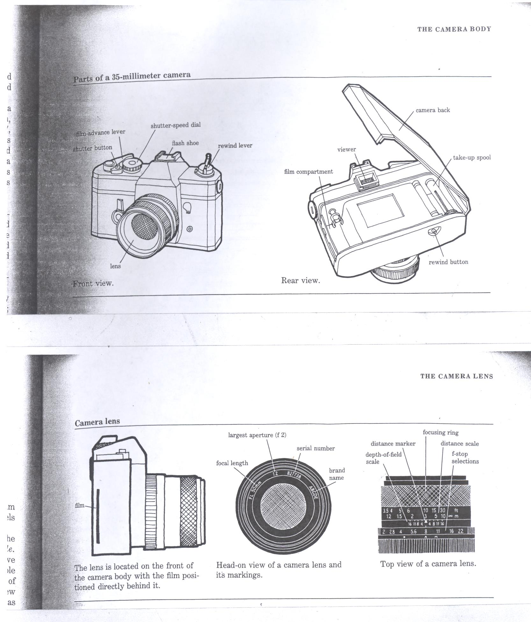

How to Load 35mm film into a 35mm Camera

- Open the back of your 35mm single-lens reflex (SLR) camera by lifting the top of the film rewind dial.
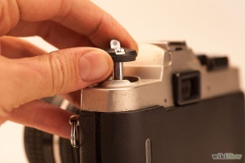
- Insert the 35mm film cassette into the left side of the camera back. Once inserted, push the film rewind dial down to lock the film canister into place.
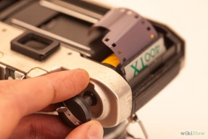
- Pull a small amount of film from the cassette, across the camera back, and insert the film leader into a slot on the film take-up reel.
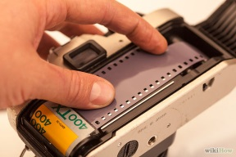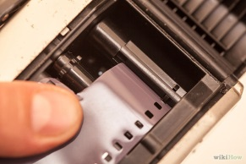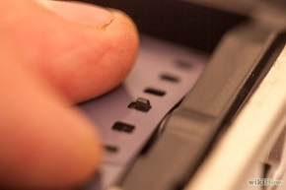
- When the film is in place of the take-up reel, advance the film using the film advance lever. If the film has started to wind around the take-up reel, close the back of your camera.
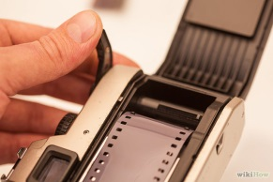
- With the camera back closed, release the shutter and continue advancing the film with the film advance lever until the indicator reads frame 1.
