Studio in Photography

Mr. Martin

Assignment #8

**Social Comment**

***Social commentary*** in photography is used to convey a message to the public with the hope to change their perception and attitudes toward a certain social issue.

[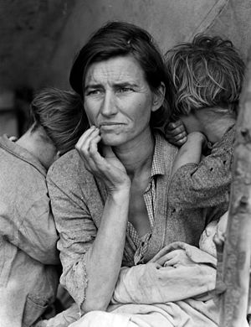](http://en.wikipedia.org/wiki/Image:Lange-MigrantMother02.jpg)***Photojournalism*** is a particular form of journalism that creates images in order to tell a story. It is now usually understood to refer only to still images, and in some cases to video used in broadcast journalism. Some characteristics are:

***Timeliness*** — the images have meaning in the context of a published chronological record of events.

***Objectivity*** — the situation implied by the images is a fair and accurate representation of the events they depict.

***Narrative*** — the images combine with other news elements, to inform and give insight to the viewer or reader.

**Dorothea Lange -** Migrant Mother

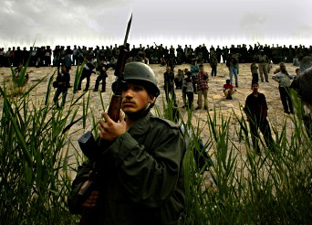 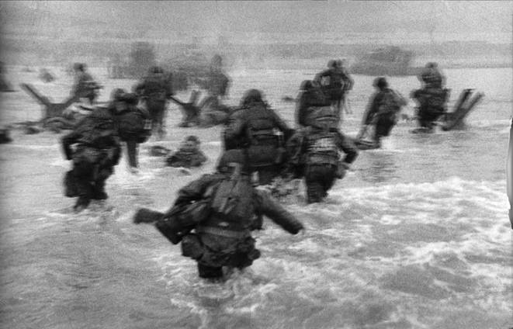 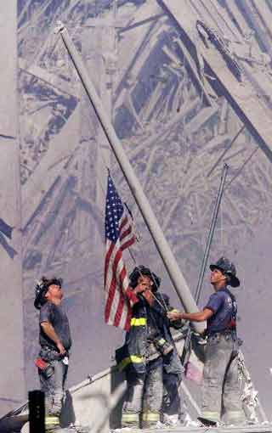

**Carolyn Cole** **Robert Capa**  **Thomas E. Franklin**

***Assignment***: Celebrate the power of pictures to make a statement.

Think outside the box.

Alter our focus.

Pictures are sometimes beautiful, often striking-and undeniably powerful.