Name:_______________________________ Due Date:________________
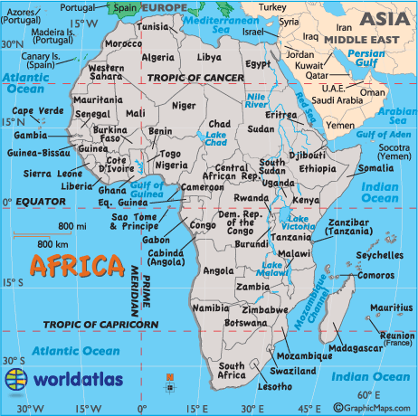
African Country Postcard Project
Country:__________________
Capital: __________________

Directions: We have been studying the geography of Africa and how its physical features, climate/vegetation, and natural resources affect people’s lives. Imagine that you are visiting the capital of a particular country in Africa and you get to experience what life is like there. Now, write and design a postcard to describe the specific details that you have learned about this country. Explain about how people live, what they eat, landforms and vegetation you see, weather, etc. You can pretend to write the postcard to someone back home. Please use the following format:

Front of Postcard Back of Postcard
Pictures with text details (facts)  Country flag  Creative decorations | Write the message in a letter format. Include the date, greeting, indented body paragraph(s), closing, and signature. Include at least 8 different facts with specific details from research.  Proper To and From addresses

Steps to Project Completion:
Dates | Steps | Actions
 | #1 | Research using a variety of databases, websites, and books  Cite sources along the way using the MLA format: pictures and research must be cited  You must have one database and print source/book cited
 | #2 | Complete the graphic organizer and other relevant notes
 | #3 | Write the letter using research notes
 | #4 | Type up the letter in a postcard format  (use postcard template from website)
 | #5 | Add pictures/facts, country flag, and other colorful decorations  Cite picture sources on Works Cited page
 | #6 | Turn in completed project including research notes, postcard, and sources cited in a word document

