Name:____________________

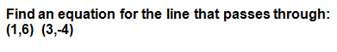

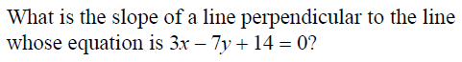

- Define the following words:
Parallel Lines:

Perpendicular Lines:

Line:

Point:

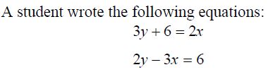

Tell me what, if anything, about these two lines are special. (Parallel, Perpendicular, or neither) Justify with your work.

- What would be the equation of a line that is perpendicular to the line $4x+2y=10$, which also passes through the point (6,2)?

