Residential Electrical Code Requirements

Your affordable house should comply with the following residential code requirements. These code requirements are reproductions of select sections of the 2012 International Residential Code for One- and Two-Family Dwellings (IRC) code requirements and represent a small fraction of the requirements imposed by the IRC and/or local jurisdictions. Therefore, numbering may not be sequential. In some cases, the sections reproduced here refer to additional IRC sections not included in this document.

To access the entire IRC, visit https://codes.iccsafe.org/public/.

IRC CHAPTER 39 POWER AND LIGHTING DISTRIBUTION

SECTION E3901 RECPTACLE OULETS
E3901.2 General purpose receptacle distribution. In every kitchen, family room, dining room, living room, parlor, library, den, sun room, bedroom, recreation room, or similar room or area of dwelling units, receptacle outlets shall be installed in accordance with the general provision specified in Sections E3901.2.1 through E3901.2.3 (see Figure E3901.2).
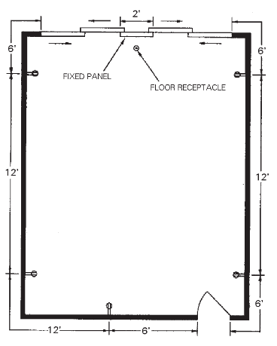
For SI: 1 foot = 304.8mm
FIGURE E3901.2
GENERAL USE RECEPTACLE DISTRIBUTION

E3901.2.1 Spacing. Receptacles shall be installed so that no point measured horizontally along the floor line in any wall space is more than 6 feet (1829 mm) from a receptacle outlet.
E3901.2.2 Wall space. As used in this section a wall space shall include the following:
1. Any space that is 2 feet or more in width, including space measured around corners, and that is unbroken along the floor line by doorways, fireplaces, and similar openings.
2. The space occupied by fixed panels in exterior walls, excluding sliding panels.
3. The space created by fixed room dividers such as railings and freestanding bar-type counters.
E3901.2.3 Floor receptacles. Receptacle outlets in floors shall not be counted as part of the required number of receptacle outlets unless they are located within 18 inches of the wall.
E3901.2.4 countertop receptacles. Receptacles installed for countertop surfaces as specified in Section E3901.4 shall not be considered as the receptacles required by Section E3901.2
E3901.4 Countertop receptacles. In kitchens, pantries, breakfast rooms, dining rooms and similar areas of dwelling units a receptacle outlet shall be installed in accordance with Sections E3901.4.1 through E3901.4.5 (see Figure E3901.4).
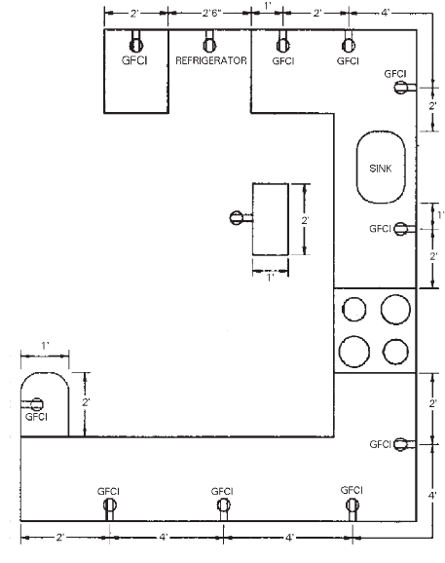
For SI: 1 foot = 304.8 mm.
FIGURE E3901.4
COUNTERTOP RECEPTACLES
E3901.4.1 Wall countertop space. A receptacle outlet shall be installed at each wall countertop space 12 inches (305 mm) or wider. Receptacle outlets shall be installed so that no point along the wall line is more than 24 inches (610 mm), measured horizontally from a receptacle outlet in that space.
Exception: Receptacle outlets shall not be required on a wall directly behind a range, counter-mounted cooking unit or sink in the installation described in Figure E3901.4.1.
E3901.4.2 Island countertop spaces. At least one receptacle outlet shall be installed at each island countertop space with a long dimension of 24 inches (610 mm) or greater and a short dimension of 12 inches (305 mm) or greater.
E3901.4.3 Peninsular countertop space. At least one receptacle outlet shall be installed at each peninsular countertop space with a long dimension of 24 inches (610 mm) or greater and a short dimension of 12 inches (305 mm) or greater. A peninsular countertop is measured from the connecting edge.
E3901.4.4 Separate spaces. Countertop spaces separated by range tops, refrigerators, or sinks shall be considered as separate countertop spaces in applying the requirements of Sections E3901.4.1, E3901.4.2 and E3901.4.3. Where a range, counter-mounted cooking unit, or sink is installed in an island or peninsular countertop and the depth of the countertop behind the range, counter-mounted cooking unit, or sink is less than 12 inches (305 mm), the range, counter-mounted cooking unit, or sink has divided the countertop space into two separate countertop spaces as defined in Section E3901.4.4. Each separate countertop space shall comply with the applicable requirements of this section.
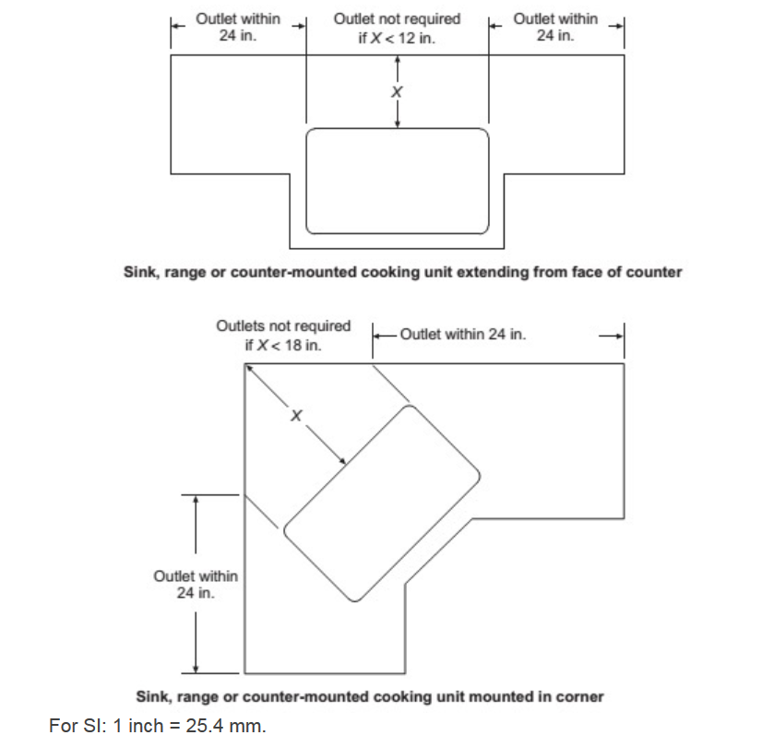
FIGURE E3901.4.1
DETERMINATION OF AREA BEHIND SINK OR RANGE

E3901.4.5 Receptacle outlet location. Receptacle outlets shall be located not more than 20 inches (508 mm) above the countertop. Receptacle outlets shall not be installed in a face-up position in the work surfaces or countertops. Receptacles outlets rendered not readily accessible by appliances fastened in place, appliance garages, sinks or rangetops as addressed in the exception to Section E3901.4.1, or appliances occupying dedicated space shall not be considered as these required outlets.
Exception: Receptacle outlets shall be permitted to be mounted not more than 12 inches (305 mm) below the countertop in construction designed for the physically impaired and for island and peninsular countertops where the countertop is flat across its entire surface and there are no means to mount a receptacle within 20 inches (508 mm) above the countertop, such as in an overhead cabinet. Receptacles mounted below the countertop in accordance with this exception shall not be located where the countertop extends more than 6 inches (152 mm) beyond its support base.

E3901.5 Appliance receptacles outlets. Appliance receptacle outlets installed for specific appliances, such as laundry equipment, shall be installed within 6 feet (1829 mm) of the intended location of the appliance.

E3901.6 Bathroom. At least one wall receptacle outlet shall be installed in bathrooms and such outlet shall be located within 36 inches (914 mm) of the outside edge of each lavatory basin. The receptacle outlet shall be located on a wall or partition that is adjacent to the lavatory basin location, located on the countertop, or installed on the side or face of the basin cabinet not more than 12 inches (305 mm) below the countertop.
Receptacle outlets shall not be installed in a face-up position in the work surfaces or countertops in a bathroom basin location.
E3901.7 Outdoor outlets. At least one receptacle outlet that is accessible while standing at grade level and located not more than 6 feet, 6 inches (1981 mm) above grade, shall be installed outdoors at the front and back of each dwelling unit having direct access to grade. Balconies, decks, and porches that are accessible from inside of the dwelling unit shall have at least one receptacle outlet installed within the perimeter of the balcony, deck, or porch. The receptacle shall be located not more than 6 feet, 6 inches (1981 mm) above the balcony, deck, or porch surface.
E3901.8. Laundry areas. At least one receptacle outlet shall be installed to serve laundry appliances.
E3901.10 Hallways. Hallways of 10 feet (3048 mm) or more in length shall have at least one receptacle outlet. The hall length shall be considered the length measured along the centerline of the hall without passing through a doorway.
E3901.11 Foyers. Foyers that are not part of a hallway and that have an area that is greater than 60 ft² (5.57 m²) shall have a receptacle(s) located in each wall space that is 3 feet (914 mm) or more in width and unbroken by doorways, floor-to-ceiling windows, and similar openings.

SECTION E3902 GROUND-FAULT AND ARC-FAULT CIRCUIT-INTERRUPTER PROTECTION
E3902.1 Bathroom receptacles. All 125-volt, single-phase, 15- and 20-ampere receptacles installed in bathrooms shall have ground-fault circuit-interrupter protection for personnel.
E3902.2 Garage and accessory building receptacles. All 125-volt, single-phase, 15- and 20-ampere receptacles installed in garages and grade-level portions of unfinished accessory buildings used for storage or work areas shall have ground fault circuit-interrupter protection for personnel.
E2902.3 Outdoor receptacles. All 125-volt, single-phase, 15- and 20-ampere receptacles installed outdoors shall have ground-fault circuit-interrupter protection for personnel.
E3902.6 Kitchen receptacles. All 125-volt, single-phase, 15- and 20-ampere receptacles that serve countertop surfaces shall have ground-fault circuit-interrupter protection for personnel.
E3902.7 Sink receptacles. All 125-volt, single-phase, 15- and 20-ampere receptacles that are located within 6 feet (1829 mm) of the outside edge of a sink that is located in an area other than a kitchen, shall have ground-fault circuit-interrupter protection for personnel. Receptacle outlets shall not be installed in a face-up position in the work surfaces or countertops.

SECTION E3903 LIGHTING OUTLETS

E3903.1 General. Lighting outlets shall be provided in accordance with Sections E3903.2 through E3903.4.

E3903.2 Habitable rooms. At least one wall switch-controlled lighting outlet shall be installed in every habitable room and bathroom.
Exceptions:
    - In other than kitchens and bathrooms, one or more receptacles controlled by a wall switch shall be considered equivalent to the required lighting outlet.
    - Lighting outlets shall be permitted to be controlled by occupancy sensors that are in addition to wall switches, or that are located at a customary wall switch location and equipped with a manual override that will allow the sensor to function as a wall switch.
E3903.3 Additional locations. At least one wall-switch-controlled lighting outlet shall be installed in hallways, stairways, attached garages, and detached garages with electric power.
At least one wall-switch-controlled lighting outlet shall be installed to provide illumination on the exterior side of each outdoor egress door having grade level access, including outdoor egress doors for attached garages and detached garages with electric power. A vehicle door in a garage shall not be considered as an outdoor egress door.
Where one or more lighting outlets are installed for interior stairways, there shall be a wall switch at each floor level and landing level that includes an entryway to control the lighting outlets where the stairway between floor levels has six or more risers.
Exception: In hallways, stairways, and at outdoor egress doors, remote, central or automatic control of lighting shall be permitted.
E3903.4 Storage or equipment spaces. In attics, under-floor spaces, utility rooms and basements, at least one lighting outlet shall be installed where these spaces are used for storage or contain equipment requiring servicing. Such lighting outlet shall be controlled by a wall switch or shall have an integral switch. At least one point of control shall be at the usual point of entry to these spaces. The lighting outlet shall be provided at or near the equipment requiring servicing.

