Exponential & Logs - Solving Log Equations Name ____________________________
A2RCC U3D7 Word Problems

Use the reference table to the right to assist you in answering questions 1-5.
$$Half-Lifes$$
$$As-81=33seconds$$
$$Au-198=2.69 days$$
$$C-14=5730 years$$
- Approximately how many seconds does it take a 100g sample of As-81 to decay to 6.25g?

- Approximately how many days does it take a 180g sample of Au-198 to decay to $1/8$ its original mass?

- What percent, to the nearest hundredth of a percent, of a sample of As-81 remains un-decayed after 43.2 seconds?

- What is the half-life of a radioactive isotope if a 500g sample decays to 62.5g in 24.3 hours?

- Approximately how old is a bone if it presently contains 0.3125gof C-14, but it was estimated to have originally contained 80g of C-14?

- On average, college seniors graduating in 2012 could compute their growing student loan debt using the function $D\left(t\right)=29,400{(1.068)}^{t}$, where $t$ is time in years. Which expression is equivalent to $29,400{(1.068)}^{t}$ and could be used by students to identify an approximate daily interest rate on their loans?

- $29,400{\left({1.068}^{\frac{1}{365}}\right)}^{t}$
- $29,400{\left(\frac{1.068}{365}\right)}^{365t}$
- $29,400{\left(1+\frac{1.068}{365}\right)}^{t}$
- $29,400{\left({1.068}^{\frac{1}{365}}\right)}^{365t}$
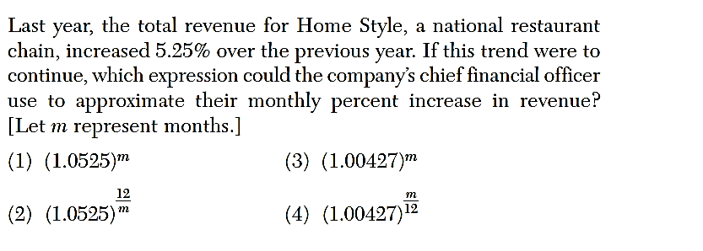

Explain your choice.

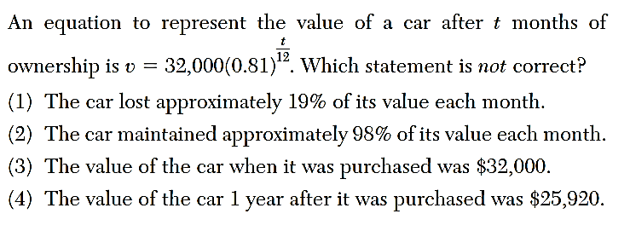

- Angie found that the number of white-winged crossbills in an area can be represented by the formula$C=550({1.08)}^{t}$, where $t$ represents the number of years since 2010. Which equation correctly represents the number of white-winged crossbills in terms of the monthly rate of population growth?

- $C=550{(1.00643)}^{t}$ (3) $C=550{(1.00643)}^{\frac{t}{12}}$
- $C=550{(1.00643)}^{12t}$ (4) $C=550{(1.08)}^{12t}$
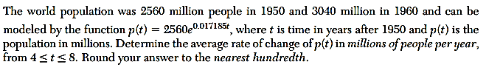

- Grace pays a $712 premium for house loan. If the premium increases at an annual rate of 6% compounded quarterly, how many years will it take for the premium to be $898.90?

