Name ____________ Comparative Advantage
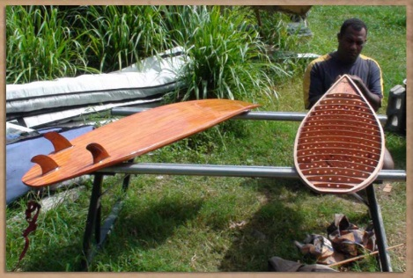

Pretend that Norway and Fiji are the only two nations in the world and they only trade skis and surfboards. In one hour Norway can either produce 10 skis or 5 surfboards while Fiji can produce 2 skis or 8 surfboards.

1. What do Economists call such pretending?
2. Who has the absolute advantage in skis? In surfboards?
3. Illustrate their choices on the same PPF graph using different colors for each nation
4. Calculate the opportunity cost for each nation.
5. Who should produce skis? How about Surfboards?
6. Explain why?
7. Who should trade for skis? How about Surfboards?
8. Discuss the real world application of comparative advantage
Country | Skis | Surfboards
Norway | 10 | 5
Fiji | 2 | 8

