Name _________________________________ Date Due:
Algebra 1 Regents Review Packet #8
Directions: Choose the best answer. Answer ALL questions. Show ALL work in column 2. If there is no mathematical work to be shown, write an explanation or definition to support your answer!
1. Mrs. Allard asked her students to identify which of the polynomials below are in standard form and explain why.
I. 15x⁴ − 6x + 3x² − 1
II. 12x³ + 8x + 4
III. 2x⁵ + 8x² + 10x
Which student’s response is correct?
- Tyler said I and II because the coefficients are decreasing.
- Susan said only II because all the numbers are decreasing.
- Fred said II and III because the exponents are decreasing.
- Alyssa said II and III because they each have three terms.
2.Which expression is a solution for the equation
2x² – x = 7?
- 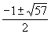
- 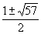
- 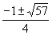
- 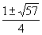
3. Olivia entered a baking contest. As part of the contest, she needs to demonstrate how to measure a gallon of milk if she only has a teaspoon measure. She converts the measurement using the ratios below:
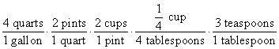
Which ratio is incorrectly written in Olivia’s conversion?
- 1. 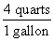 3. 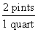
- 2. 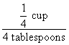 4. 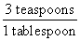
4.What is the solution to the inequality 2 + $\frac{4}{9}$ x ≥ 4 + x?
- x ≤ $\frac{-18}{5}$ 3. x ≥ $\frac{-18}{5}$

- x ≤ $\frac{54}{5}$ 4. x ≥ $\frac{54}{5}$

5.The solution to −2(1 − 4x) = 3x + 8 is
- $\frac{6}{11}$ 3. $\frac{-10}{7}$

- 2 4. −2

6.Joy wants to buy strawberries and raspberries to bring to a party. Strawberries cost $1.60 per pound and raspberries cost $1.75 per pound. If she only has $10 to spend on berries, which inequality represents the situation where she buys x pounds of strawberries and y pounds of raspberries?
  - 1.60x + 1.75y ≤ 10 3. 1.75x + 1.60y ≤ 10
  - 1.60x + 1.75y ≥ 10 4. 1.75x + 1.60y ≥ 10
7.Konnor wants to burn 250 Calories while exercising for 45 minutes at the gym. On the treadmill, he can burn 6 Cal/min. On the stationary bike, he can burn 5 Cal/min. If t represents the number of minutes on the treadmill and b represents the number of minutes on the stationary bike, which expression represents the number of Calories that Konnor can burn on the stationary bike?
- b 3. 5b
- 45 – b 4. 250 − 5b
8.Which point is a solution to the system below algebraically?
y < −6x + 4
2y < −12x + 4
- (1,$\frac{1}{2}$ ) 3. (−$\frac{1}{2}$ ,5)
- (0,6) 4. (−3,2)

9.The volume of a large can of tuna fish can be calculated using the formula V = πr²h.  PART A: Write an equation to find the radius, r, in terms of V and h. |  | 10.PART B:Determine the diameter, to the nearest inch, of a large can of tuna fish that has a volume of 66 cubic inches and a height of 3.3
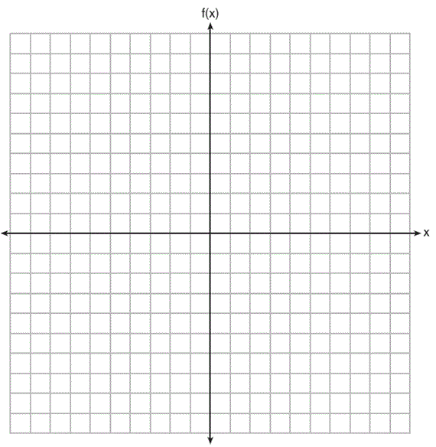
11.PART A: On the set of axes below, graph f(x) = |x – 3| + 2.
Provide a table of values

12.PART B:Describe the transformation from$f(x)=$ $\left|x\right|$

13.Ms. Tod asked her class “Is the difference of 4.2 and rational or irrational?” Patrick answered that the difference would be irrational. State whether Patrick is correct or incorrect. Justify your reasoning.

14.Factor completely the expression 49x² – 36

15.A construction worker needs to move 120 ft³ of dirt by using a wheelbarrow. One wheelbarrow load holds 8 ft³ of dirt and each load takes him 10 minutes to complete. One correct way to figure out the number of hours he would need to complete this job is
- 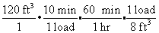
- 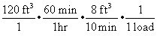
- 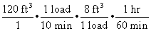
- 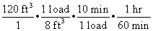
16.Find the axis of symmetry algebraically:
$$f(x)= x^{2}+3x+6$$

17.Find the vertex:

 | 18. A used car was purchased in July 2000 for $11,900. If the car depreciates 13% of its value each year, what is the value of the car, to the nearest hundred dollars, in July 2003?
19. The parents of twin boys started a college fund when the boys were 5 years old. They decided to invest $6,000 into an account that compounds quarterly at a rate of 8.6% annually.

If the parents do not invest any additional money into this fund, how much will each of the boys have toward his education when they reach 18 years old? Use the formula: 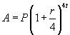, where A is the amount at the end of a specific length of time, P is the initial amount of the investment, r is the rate as a decimal and t is time. Round your answer to the nearest cent.

 | 20..Guy and Jim work at a furniture store. Guy is paid $185 per week plus 3% of his total sales in dollars, x, which can be represented by g(x) = 185 + 0.03x. Jim is paid $275 per week plus 2.5% of his total sales in dollars, x, which can be represented by f(x) = 275 + 0.025x. Determine the value of x, in dollars, that will make their weekly pay the same

